**Assignment 3**

1. Use ps to search for the “systemd” process by name.



1. Find out your terminal name. Using your terminal name, use ps to find all processes associated with your terminal.

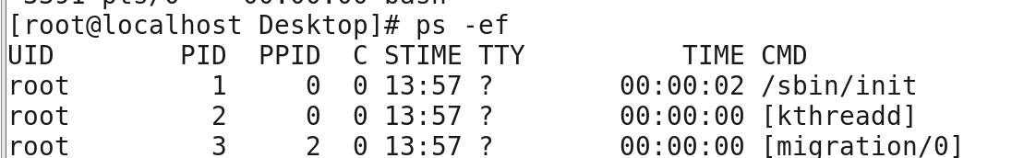

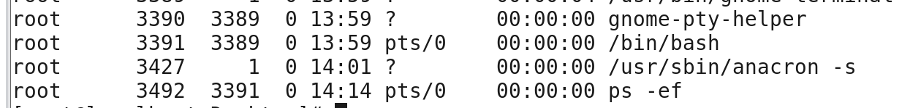

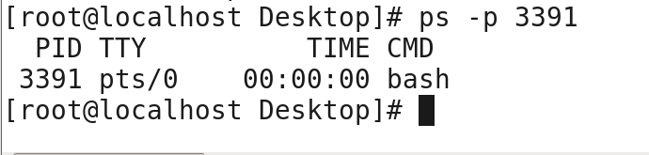

1. Check and note the process id of your shell (from the output of the above command).  Also, note the parent process id of your shell.

**PID is 3391 and PPID is 3389**

1. Start 3 instances of “sleep 123” as background processes.

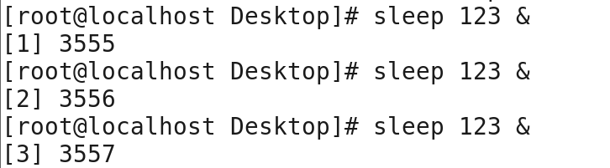

1. Check and note the process id’s of all sleep processes.

**Pid of sleep is 3555, 3556, 3557**

1. Display only those three sleep processes in top. Then quit top.



